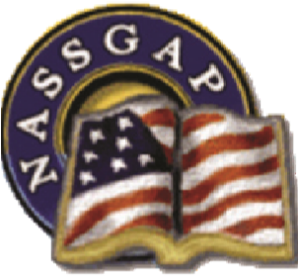

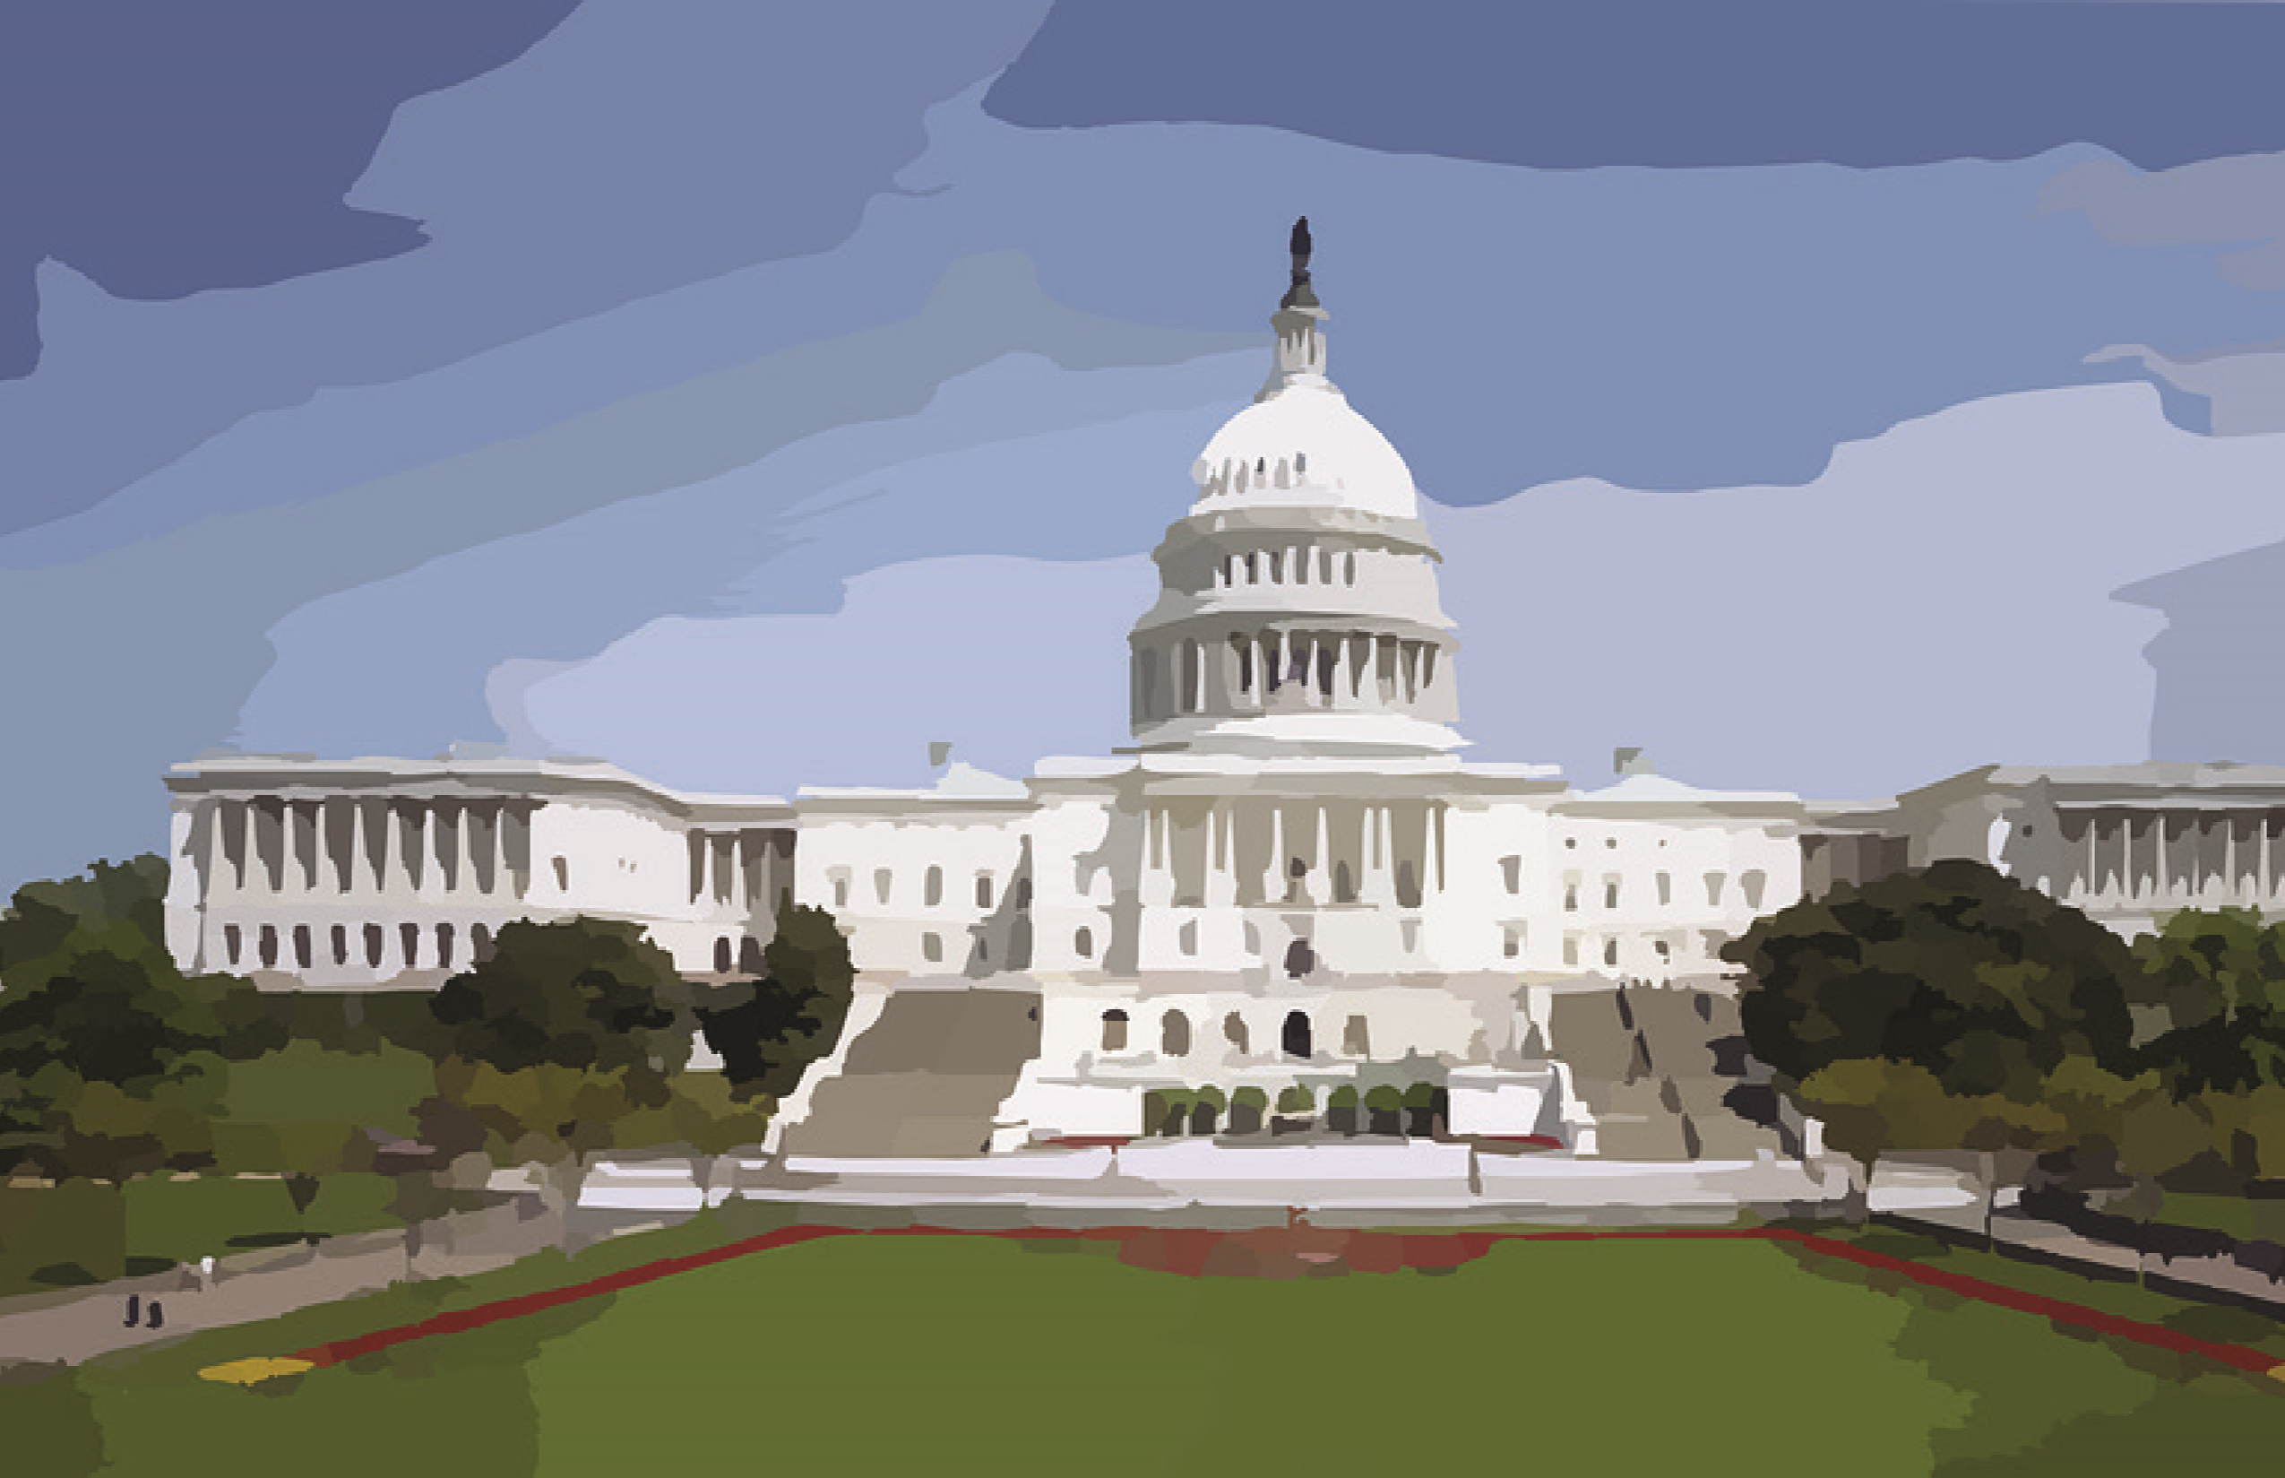

**NASSGAP’s**

**51st**

**Annual**

**Conference**

**October 24 – 27, 2017**

***Welcome to our conference***

***We are so glad you’re here***

***Enjoy this little sack of treats***

***Provided free this year!***

***Nuts for a bit of protein***

***Agua to drench the thirst***

***Stuff to do in DC***

***Snacks if you’d like that first***

***Gum to keep you busy***

***Advil to cure jetlag and***

***Peppermints for breath so***

***fresh top off this little gift bag.***



**NASSGAP’s**

**51st**

**Annual**

**Conference**

**October 24 – 27, 2017**

***Welcome to our conference***

***We are so glad you’re here***

***Enjoy this little sack of treats***

***Provided free this year!***

***Nuts for a bit of protein***

***Agua to drench the thirst***

***Stuff to do in DC***

***Snacks if you’d like that first***

***Gum to keep you busy***

***Advil to cure jetlag and***

***Peppermints for breath so***

***fresh top off this little gift bag.***