VIRTUAL - ZOOM PLATFORM
NASSGAP Annual Conference
OCTOBER 19 – 22, 2021
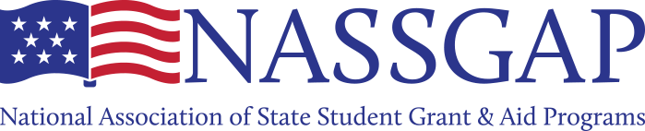
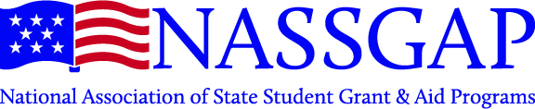

Welcome!
It’s my pleasure to welcome you all to the 2021 Annual NASSGAP Conference! I did not anticipate that I’d be writing to welcome you to yet another virtual NASSGAP Conference in 2021. But given the success of the virtual conference in 2020, I have nothing but highest confidence in the Conference Committee's ability to pull it off again.
Even though I’d rather be in-person, the virtual modality has allowed the association to expand its reach within NASSGAP member agencies, allowing many more staff the opportunity to engage, learn, and get involved - a core piece of our association’s mission and purpose. I know we currently have our sights set on an in-person conference in the fall of 2022, but the Executive Committee will be prepared to offer a virtual option again, if needed.
For me the annual NASSGAP Conference is a time of excitement, offering an opportunity to collaborate with colleagues and learn about new ideas, programs, and processes that have been proposed or initiated across the states. This knowledge sharing provides valuable insight into what our futures may hold, as new policies/programs enacted in one state tend to show up in others in due time.
Thinking back on the year past - so much has changed, and so much remains the same. As professionals, what we hoped for in 2021 may not have materialized; but we’re still here, and we keep moving forward in the best interests of the students and other constituents that we serve. And so the common bond of our work brings us together again to share ideas, perspectives, and our own learned experience to the benefit of each other. I cannot wait.
A sincere and heartfelt welcome to all members, new and seasoned, to this year’s annual conference.

Todd Brown
2020-21 NASSGAP President

ZOOM Away with Us
The 2021 NASSGAP Annual Conference is being delivered via ZOOM. In case you are not already a ZOOM expert, ZOOM is a web-based conferencing platform that allows people to gather virtually with both audio and video capabilities. (Click here and here and here for some quick tips if you’re new to ZOOM.)

ZOOM Access Link and Phone Number: Your ZOOM access information is the same for all sessions but is unique to you. After submitting your registration form through the NASSGAP website, you received a confirmation email with a link to register through Zoom. After registering through Zoom, you received your unique ZOOM access link and a calendar invite. If you cannot find it, email charles.contero-puls@highered.texas.gov, and he will re-send your link.

Equipment Needed: A computer with a camera, audio speakers and microphone are the preferred equipment for the best meeting experience. You may also join the meeting by audio only from a phone. You can test your system before joining at https://zoom.us/test.

Waiting Room: Upon first accessing the meeting, all participants will be placed in a waiting room. A meeting moderator will admit you. The waiting room is a ZOOM security feature that protects against uninvited guests.

Participant Audio: Participant audio will be automatically muted upon entering the meeting. However, participants will be able to unmute themselves to ask questions or engage in discussion. A microphone icon is located on the lower left-hand side of your ZOOM Dashboard. Click the icon once to mute (red slash will appear) or unmute (red slash will disappear). Please remain on mute unless you are speaking. The speaker or moderator will call for questions at the appropriate point(s) during the presentation. At that point you should “raise your hand” (click on “reactions” to access this option).

Participant Video: Participant video will be automatically turned off upon entering the meeting. However, we encourage you turn your video on if you are comfortable. Being able to see the faces of your colleagues makes for a more engaging meeting. The video icon is located on the lower left-hand side of your Zoom dashboard. Click the icon once to turn off the video (red slash will appear) or turn on the video (red slash will disappear).

Reactions: If you press one of the reaction icons (thumbs up or clapping hands), a reaction emoji will appear in your ZOOM window. The emoji will automatically disappear after 10 seconds.

Chat: You can use the chat box for assistance or to ask questions. When posting in the chat box, you can select a conference participant to message individually or you can post the message for everyone.

Technical or Meeting Support During the Conference: For technical or other meeting support during the conference, please send an email to charles.contero-puls@highered.texas.gov, or send Charles a message directly via the Zoom.

2020–2021 Executive Committee and Committee Chairs
President Treasurer Federal Relations
Todd Brown Leroy Wade Elizabeth McCloud, Chair
Iowa Missouri Pennsylvania
(515) 725-3405 (573) 751-2361 (717) 720-1600
Todd.brown@iowa.gov leroy.wade@dhewd.mo.gov Elizabeth.McCloud@pheaa.org

President-Elect Treasurer-Elect Membership Committee
Katie Harrison Harrison Rommel, Ph.D. Jennifer Lanphear, Chair
South Carolina New Mexico Maine
(803) 896-1120 (505) 476-8415 (207) 620-3548
katie@sctuitiongrants.org rdavis@nshe.nevada.edu jlanphear@famemaine.com

Past-President Member-at-Large Web Committee
Jennifer Rogers Renée Davis J. Ritchie Morrow, Chair
Mississippi Nevada Nebraska
(601) 432-6791 (775) 784-3447 (402) 471.0032
jrogers@mississippi.edu rdavis@nshe.nevada.edu Ritchie.Morrow@nebraska.gov

Secretary Member-at-Large
Becky Thompson Jennifer Lanphear
Washington Maine
(253) 579-2108 (207) 620-3548
BeckyT@wsac.wa.gov jlanphear@famemaine.com

Thank you to our 2021 Conference Planning Committee!
TITLE | NAME
Members at Large and Conference Co-chairs | Renée Davis (NV) and  Jennifer Lanphear (ME)
President | Todd Brown (IA)
Past President | Jennifer Rogers (MS)
Treasurer | Leroy Wade (MO)
Federal Relations Committee, Chair | Elizabeth McCloud (PA)
Web Committee, Chair | Ritchie Morrow (NE)
Director of Federal Relations | Frank Ballmann (NY/NASSGAP)
Volunteer | Mia Candelaria (NM)
Volunteer | Zachary Christian (SC)
Volunteer | Charles Contero-Puls (TX)
Volunteer | Diane Lindeman (KS)

CONFERENCE AGENDA & PROGRAM
***NOTE: All times are in Eastern Daylight Time (EDT)***
TUESDAY, OCTOBER 19, 2021 Daily Moderator: Todd Brown
12:00 PM – 12:50 PM | President’s Welcome and Housekeeping  Todd Brown, 2020-21 NASSGAP President
1:00 PM – 1:50 PM | Federal Student Aid Update  Richard Cordray, Chief Operating Officer  Federal Student Aid  States rely on the Office of Federal Student Aid to deliver the FAFSA data that helps states award over $12 billion in student aid annually to students pursuing postsecondary education. In this keynote address session, Richard Cordray, the Chief Operating Officer of Federal Student Aid will share his vision for updating the FAFSA process, protecting students and borrowers and helping states achieve their degree completion goals for students of all backgrounds.
2:00 PM – 2:50 PM | NASFAA Update – Inside the Beltway  Karen McCarthy, Vice President of Public Policy and Federal Relations  National Association of Student Financial Aid Administrators (NASFAA)  This NASFAA update will provide a high-level landscape of the Washington political climate with a focus on federal financial aid policy and how it has impacted students and institutions in recent years. Overall trends in student aid will be discussed, including an overview of reauthorization proposals and predictions for how student aid funding will fare in future budget negotiations. The session will also provide an overview of NASFAA-led projects, services, and advocacy efforts.
3:00 PM – 3:50 PM | Need-Based Aid Boosts Graduation Rates: Evidence From Recent Research  David Socolow, Executive Director  New Jersey Higher Education Student Assistance Authority (HESAA)  Drew Anderson, Ph.D. RAND Corporation  This session will discuss the value of partnerships between state grant aid programs and researchers. State administrators and independent researchers each have valuable expertise to share and a set of burning questions, and each can get their questions answered by working together. We’ll share the results from a recent set of reports where independently-funded researchers from the RAND Corporation studied New Jersey's Tuition Aid Grant (TAG) using de-identified data supplied by the state’s financial aid agency.
4:00 PM – 5:00 PM | State Roll Call  Katie Harrison, Facilitator  Executive Director  South Carolina Higher Education Tuition Grants Commission  NASSGAP President-elect  Each state is allotted 5 minutes. States presenting today: New York, Maryland, Georgia, Maine, Texas, Louisiana, North Dakota, Idaho, Massachusetts, and Nevada
5:00 PM – 5:30 PM | After-Hours Social  Members are randomly sorted into breakout rooms and then move independently to other rooms as they desire. Locations are: Cooney’s Tavern (Des Moines, IA), Death and Taxes (Reno, NV), and The Quarry Tap Room (Hallowell, ME), Hollow Creek Distillery (Leesville, SC)
TUESDAY October 19, 2021 (cont.)

CONFERENCE AGENDA & PROGRAM
***NOTE: All times are in Eastern Daylight Time (EDT)***
WEDNESDAY, OCTOBER 20, 2021 Daily Moderator: Jennifer Rogers
12:00 PM – 1:20 PM | State Roll Call  Katie Harrison, Facilitator  Executive Director  South Carolina Higher Education Tuition Grants Commission  NASSGAP President-elect  Each state is allotted 5 minutes. States presenting today: West Virginia, South Carolina, Ohio, Iowa, Kentucky, Pennsylvania, Connecticut, Montana, Indiana, Mississippi, Minnesota, Missouri, Alaska, and Michigan
1:30 PM – 2:20 PM | Updating Federal-State Partnerships  Moira Lenehan-Razzuri, Senior Policy Advisor  Office of Senator Jack Reed of Rhode Island  It has been a while since legislation was enacted relating to a federal-state partnership.  There are proposals out there relating to “free college” structured as such a partnership.  Senator Reed, who sits in the seat once held by Senator Pell (perhaps you’ve heard of  Pell grants?!?) was an advocate for LEAP, creator of the College Access Challenge  Grants and is the author of the only federal-state partnership bill NASSGAP has  endorsed in the last few years, the Partnerships for Affordability and Student Success  Act (PASS Act). We’ll hear about the PASS Act and the work Moira did to ensure  participation by states in the partnership.
2:30 PM – 3:20 PM | Evaluating the EFC to SAI Transition  Meghan Oster Ph.D.  Division Administrator for Research and Communications  Iowa College Aid  The Consolidated Appropriations Act of 2021 modified the federal financial aid needs analysis formula, and the US Department of Education plans to implement those changes for the 2024-25 FAFSA cycle. The change to the federal formula has downstream effects because many states and postsecondary institutions use the derived Expected Family Contribution (EFC, to be known in the future as Student Aid Index [SAI]) to determine aid eligibility. Therefore, Iowa College Aid staff members have simulated the new formula using historical data from the Free Application for Federal Student Aid. In this presentation, we will discuss the changes to the formula as we understand them to be from the bill and show how the new formula changes the distribution of student’s financial need calculation. Then, we will engage with participants about how we can create documenta-  tion and tools to help other states complete similar analyses using their own data.
3:30 PM – 4:20 PM | EFC to SAI – Facilitated Discussion  Elizabeth McCloud, Facilitator  Vice President, State Grant and Special Programs Pennsylvania Higher Education Assistance Authority (PHEAA)  Join your colleagues for a conversation on the upcoming shift from the Expected Family Contribution (EFC) to the new Student Aid Index (SAI), with a focus on areas where states may need to make changes to primary need-based aid programs for 2024-25 and beyond.
4:30 PM – 5:00 PM | Frank’s Federal Update  Frank Ballmann, Director, Federal Relations NASSGAP  What’s happening – or not – in Washington? Frank will talk about the latest developments – or roadblocks – as Congress tries to move ahead with the FFY22 federal budget, the President’s Build Back Better agenda and the US Department of Education has its hands full with NegReg, student loan issues – including the payment pause, PSLF reform, servicing contracts – and FAFSA implementation, both for the just released FAFSA and future changes. We’ll also talk about what’s in NASSGAP’s HEA priorities letter, what isn’t and why.
5:00 PM – 6:00 PM | After-Hours Social  Members are randomly sorted into breakout rooms and then move independently to other rooms as they desire. Locations are: Cooney’s Tavern (Des Moines, IA), Death and Taxes (Reno, NV), and The Quarry Tap Room (Hallowell, ME), Hollow Creek Distillery (Leesville, SC)
Wednesday, October 20, 2021 (cont.)
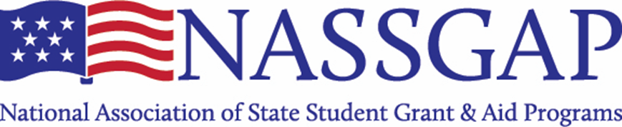

CONFERENCE AGENDA & PROGRAM
***NOTE: All times are in Eastern Daylight Time (EDT)***
THURSDAY, OCTOBER 21, 2021 Daily Moderator: Leroy Wade

12:00 PM – 12:50 PM | Reforming Student Financial Aid to Increase College Completion  Joshua Garrison,  Associate Commissioner for Legislation and Program Implementation  Indiana Commission for Higher Education  Historically, more than 15% of Indiana’s higher education budget goes toward need-based financial aid. This investment has increased access to postsecondary education for thousands of low-income Hoosiers. However, the resulting gains in college access have not been matched with gains in college completion. In 2013, the Indiana General Assembly enacted financial aid reform legislation aimed at encouraging more students to graduate from college on time. These reforms focused on preparing students for postsecondary education and encouraging students to graduate within the four years Hoosier students are eligible for state financial aid. The legislation’s key provision requires students to complete at least 30 credits during their award year to renew their state financial aid award. Since the passage of these reforms, the on-time graduation rate for recipients of Indiana’s need-based financial aid programs have more than doubled. This session will cover the impact of Indiana’s financial aid reform legislation on postsecondary access and completion.
1:00 PM – 1:50 PM | FAFSA and Verification Updates  Carrie Warick, Director of Policy and Advocacy  Bill DeBaun, Director of Data and Evaluation  National College Access Network (NCAN)  This FAFSA-focused session will cover the latest news in applying for financial aid. NCAN will share the latest from the FAFSA Tracker, including trends from the 20-21 filing cycle and early insights for the 21-22 cycle. Also covered will be verification: the impact of verification relief, the push to extend the changes, and a sneak peek at a forthcoming paper from NCAN and NAFSAA. The upcoming FAFSA simplification will also be addressed.
2:00 PM – 2:50 PM | State Roll Call  Katie Harrison, Facilitator  Executive Director  South Carolina Higher Education Tuition Grants Commission NASSGAP President-elect  Each state is allotted 5 minutes. States presenting today: Nebraska, Arkansas, Wisconsin, Alabama, Vermont, Tennessee, Oklahoma, Washington, Arizona, and North Carolina
3:00 PM – 3:50 PM | Aligning Effort to Value – Facilitated Discussion  Marilyn Cargill, Facilitator  Vice President,  Financial Aid Services, Research, Marketing and Public Relations  Vermont Student Assistance Corp (VSAC)  State aid administrators are often tasked with more than program administration – from developing policy proposals to contract management to “ad hoc” requests. This session will engage NASSGAP attendees in discussion about how to maintain strategic focus and alignment with objectives and values as you remain responsive to policy makers and partners while stretching limited resources.
4:00 PM – 5:00 PM | NASSGAP Business Meeting
5:00 PM – 5:30 PM | After-Hours Social  Members are randomly sorted into breakout rooms and then move independently to other rooms as they desire. Locations are: Cooney’s Tavern (Des Moines, IA), Death and Taxes (Reno, NV), and The Quarry Tap Room (Hallowell, ME), Hollow Creek Distillery (Leesville, SC)
Thursday, October 21, 2021 (cont.)

CONFERENCE AGENDA & PROGRAM
***NOTE: All times are in Eastern Daylight Time (EDT)***
FRIDAY, OCTOBER 22, 2021 Daily Moderator: Ritchie Morrow
12:00 PM – 12:50 PM | SHEEO UPDATE  Thomas Harnisch, Ed.D.  Vice President for Government Relations  State Higher Education Executive Officers Association (SHEEO)  This year has brought some of the most far-reaching policy proposals for  higher education in nearly a half century, with changes that fundamentally  reshape the relationship between the federal government and the states  and usher in a new era of college affordability and student success. This  session will examine and provide status updates on some of the biggest  federal higher education policy proposals of the year, including free  community college, completion grants, and Pell Grant increases. It will  also explore state efforts to increase educational attainment in a policy  environment marked by uncertainty and change and conclude with  opportunities for state higher education officials to inform the national  conversation during this pivotal time.
1:00 PM – 2:00 PM | State Roll Call  Katie Harrison, Facilitator  NASSGAP President-elect  Executive Director  South Carolina Higher Education Tuition Grants Commission  States are allotted 5 minutes. State presenting today: Virginia, California, Oregon, Utah, New Mexico, Illinois, Kansas, New Jersey, and Washington DC
2:00 PM – 2:50 PM | Final Farewell and After-Hours Social  Members are randomly sorted into breakout rooms and then move independently to other rooms as they desire. Locations are: Cooney’s Tavern (Des Moines, IA), Death and Taxes (Reno, NV), and The Quarry Tap Room (Hallowell, ME), Hollow Creek Distillery (Leesville, SC)

PRESENTERS

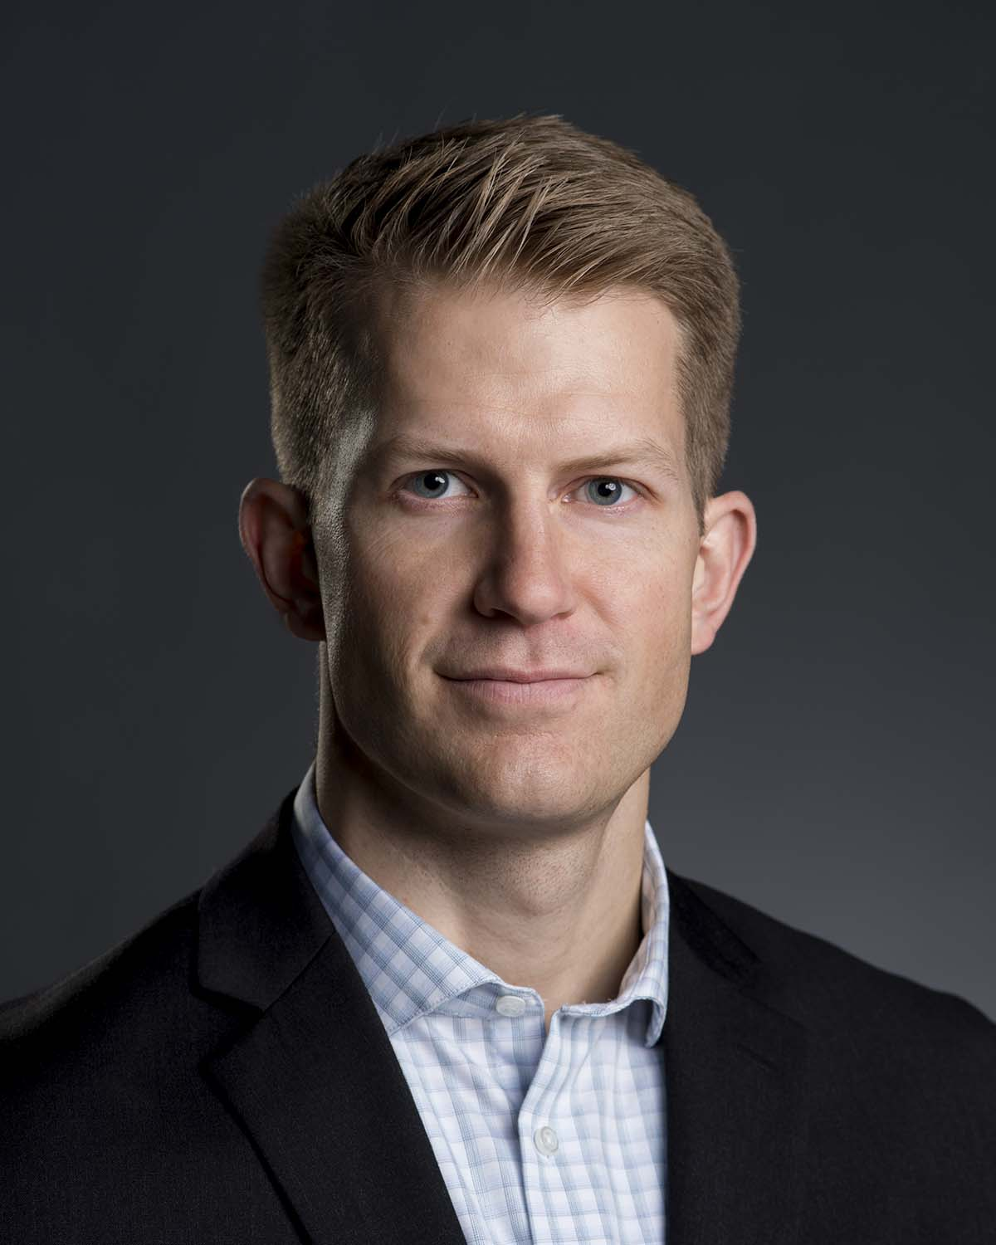
Drew M. Anderson, Ph.D.
Economist
RAND Corporation

Drew M. Anderson, PhD, is an Economist at the RAND Corporation in Santa Monica, California. At RAND he partners with leaders in government to provide objective economic analysis. Drew has studied financial aid for college from the perspective of students, aid providers, policymakers, and educators. He has published in-depth studies of the effects of state grant aid programs in Wisconsin and New Jersey. Both studies demonstrated positive effects on graduation and highlighted variation in effectiveness for students with different family income levels.

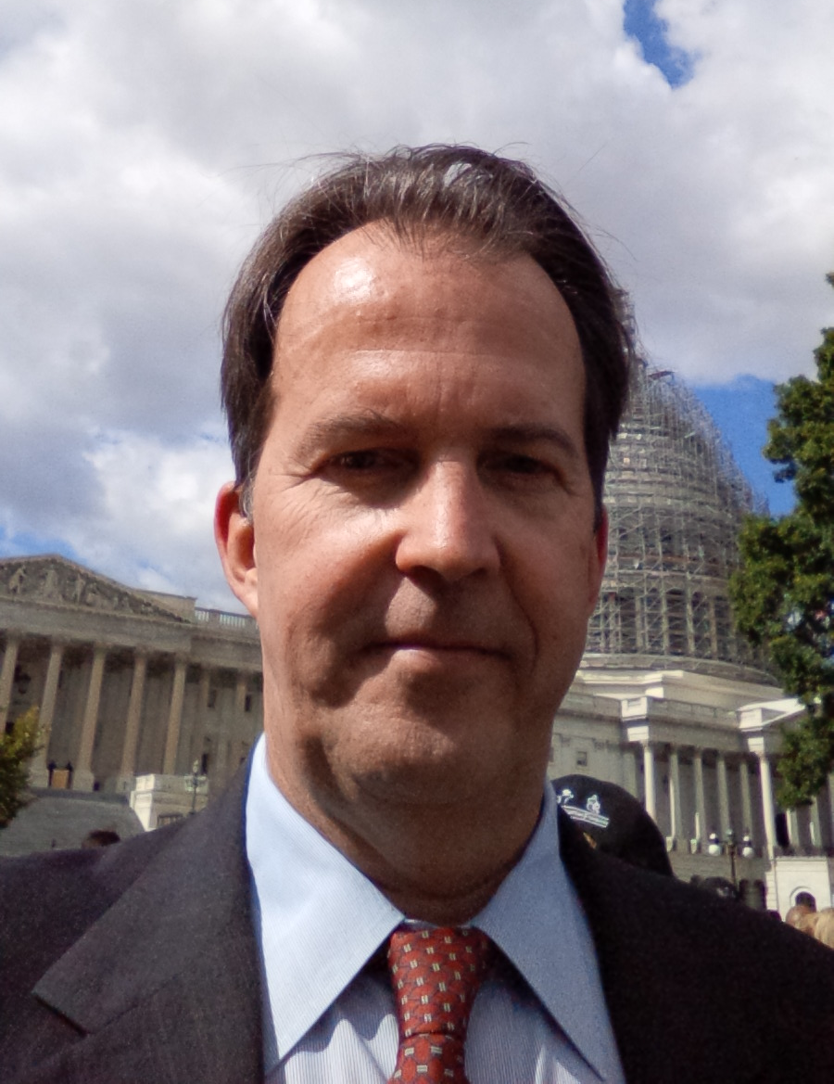
Frank Ballmann
Director, Federal Relations
New York State Higher Education Services
Corporation (HESC)

Mr. Ballmann has worked with the New York State Higher Education Services Corporation (HESC) since 2008. He initially came on board as a contractor in October 2008 and became a HESC employee in October 2009. He became the NASSGAP federal relations lead in March 2010. He has 37 years of experience in education finance and financial aid programs, not counting completing the FAFSA and receiving grants, scholarship, loans, and work-study to attend college.
Prior to HESC, he worked for a variety of organizations ranging from start-up companies to major financial institutions. He has provided education finance, college savings, and financial aid program advisory services to a wide range of organizations, including state and nonprofit agencies in Alaska, California, New York, Rhode Island, Texas, and Virginia, as well as the U.S. Department of Education.
Mr. Ballmann holds a bachelor’s degree in accounting and political science from the Wharton School of the University of Pennsylvania and has earned his CPA certificate.

Todd Brown
Division Administrator, Financial Aid Program Administration
Iowa College Aid

Todd Brown has worked in higher education financing for the past 17 years, beginning as a graduate assistant in the financial aid office at the University of Northern Iowa. He has worked for the Iowa College Student Aid Commission for the past 13 years, currently serving as division administrator for financial aid program administration. In this role he oversees the implementation, administration, and distribution of state and federal scholarship, grant, and loan repayment programs.
Mr. Brown is also the commission’s liaison to the Iowa General Assembly. He graduated from the University of Northern Iowa with a bachelor’s degree in marketing and a master’s degree in higher education administration.

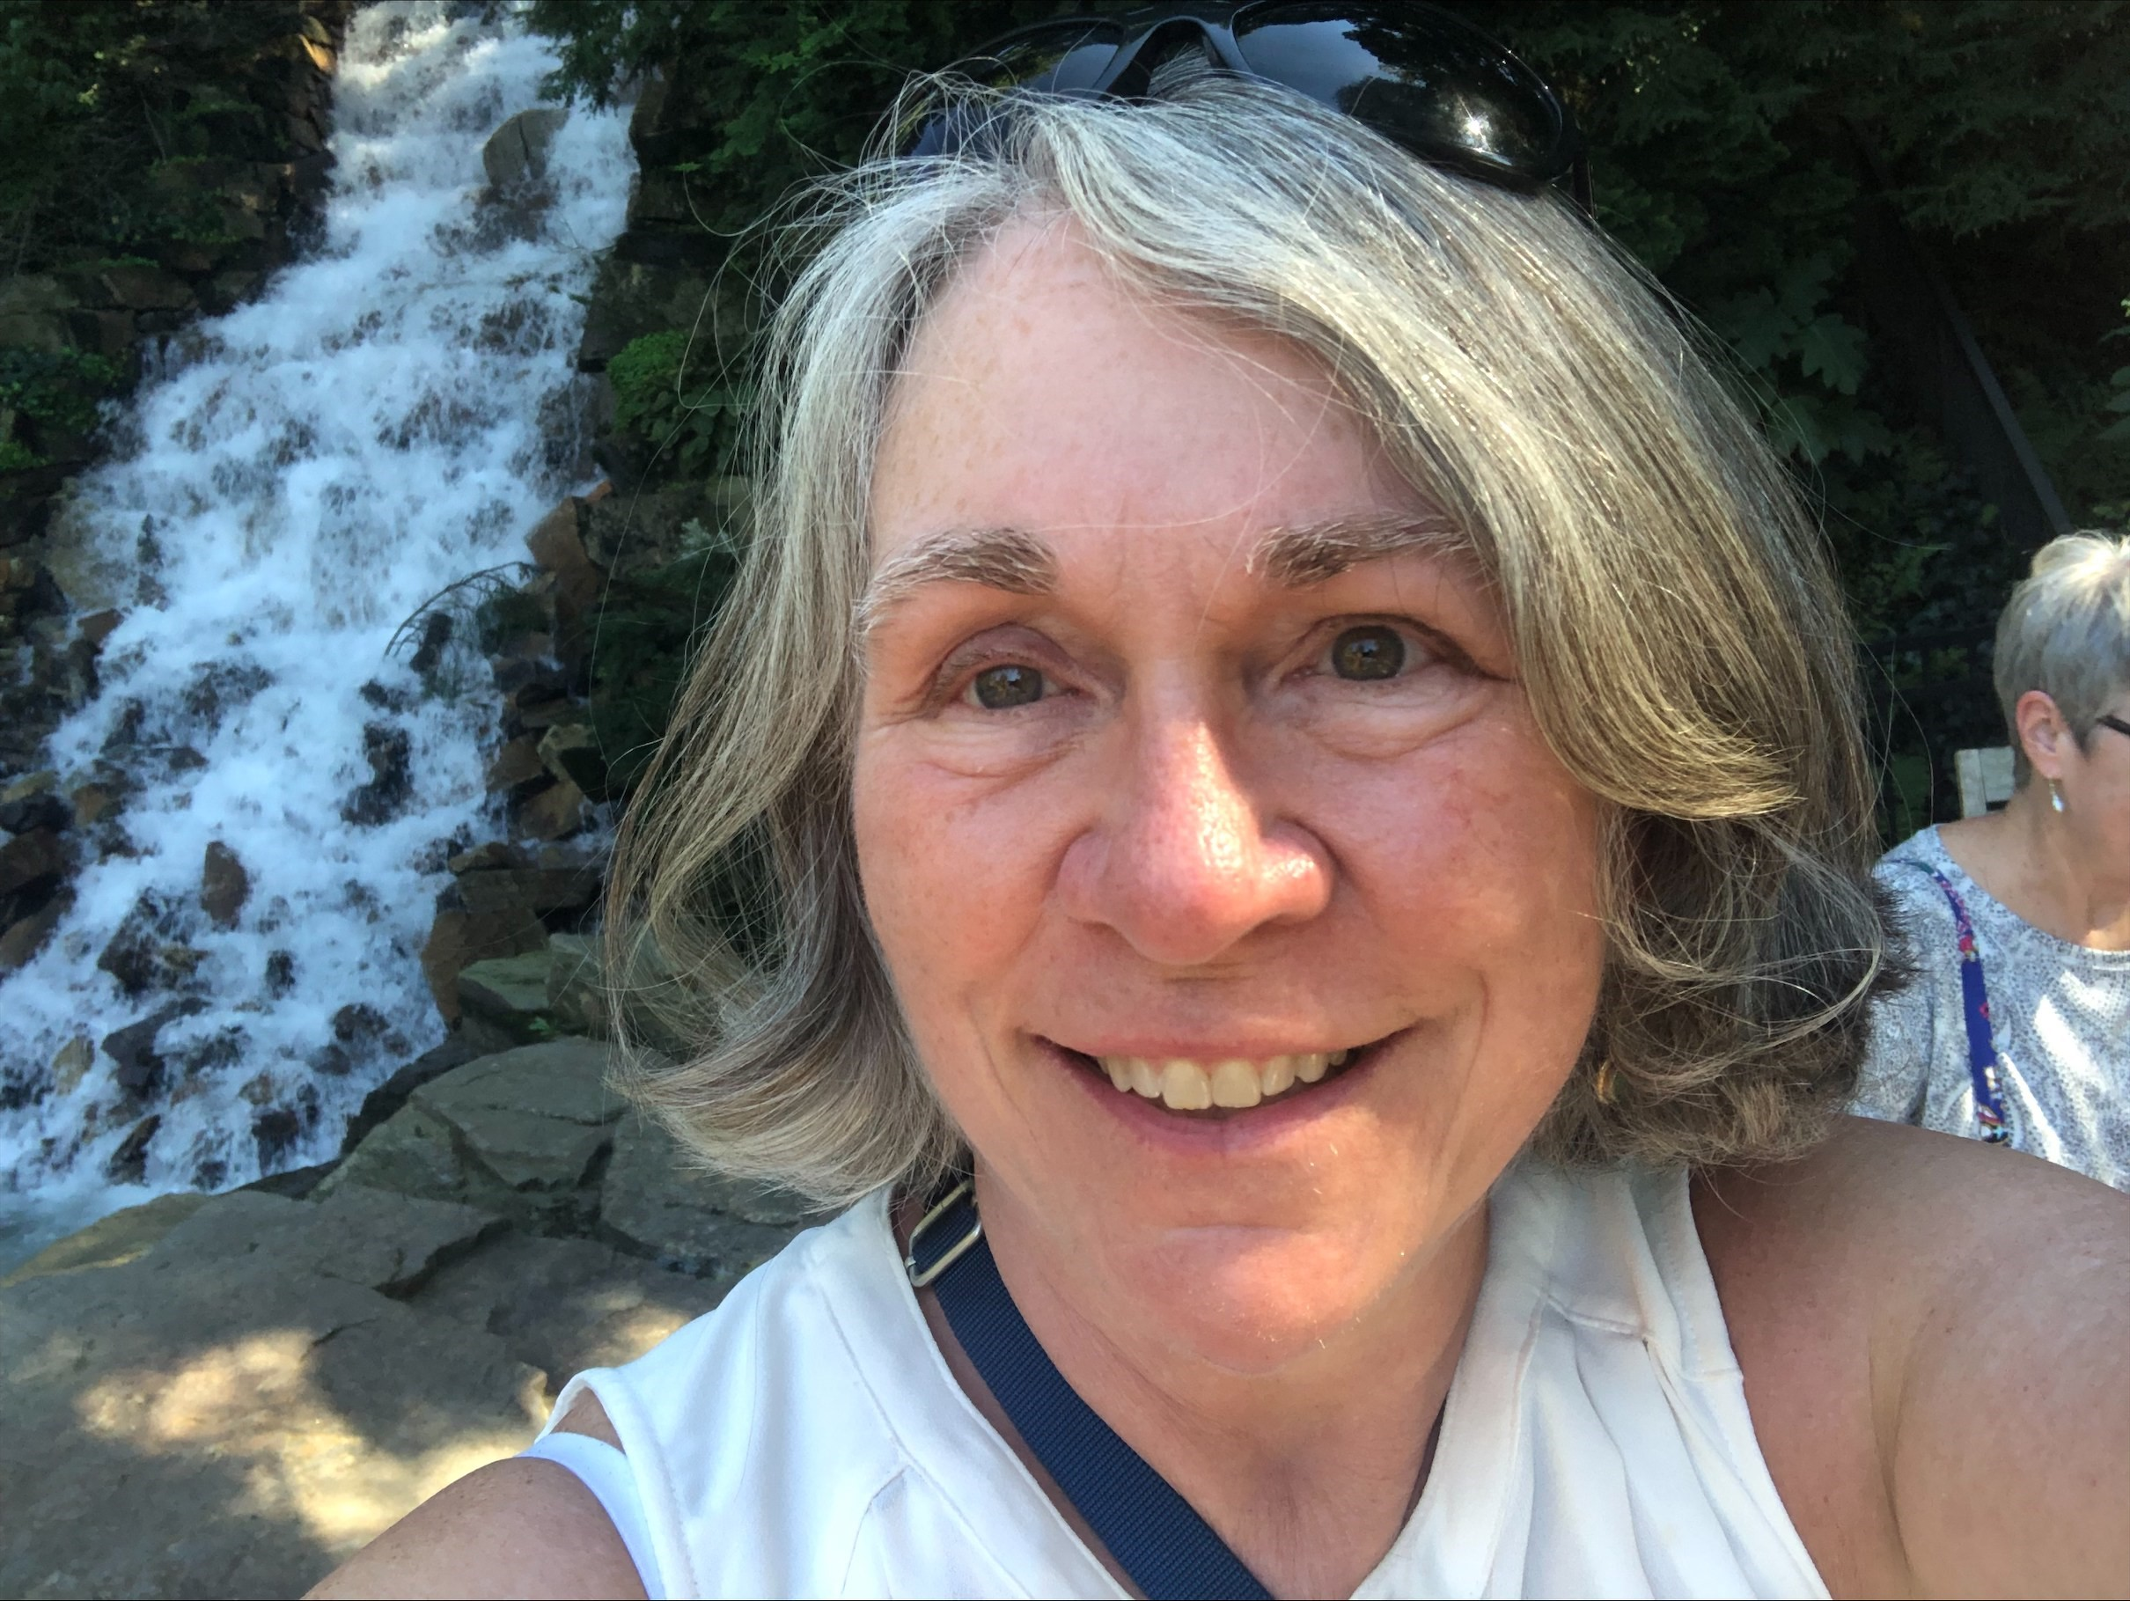
Marilyn Cargill
Vice President, Financial Aid Services, Research, Marketing and Public Relations
Vermont Student Assistance Corporation (VSAC)

Marilyn Cargill joined VSAC in 1984. In 2014 Marilyn became Vice President of Financial Aid Services, Research, Marketing and Public Relations. In her role with Financial Aid Services Marilyn oversees the State Grant Programs, Loan Origination and Servicing, and School Relations. Marilyn is a past president of NASSGAP. She has also served as an officer for the Vermont Association of Financial Aid Administrators. Marilyn currently serves on a number of community-based Boards including as Chair of her town Planning Commission.

Bill DeBaun
Director, Data and Evaluation
National College Access Network (NCAN)

Bill DeBaun is NCAN’s director of data and evaluation. In that role he researches and writes about college access and success programming that demonstrates significant results for students’ college enrollment and graduation rates while additionally providing technical assistance to other initiatives.

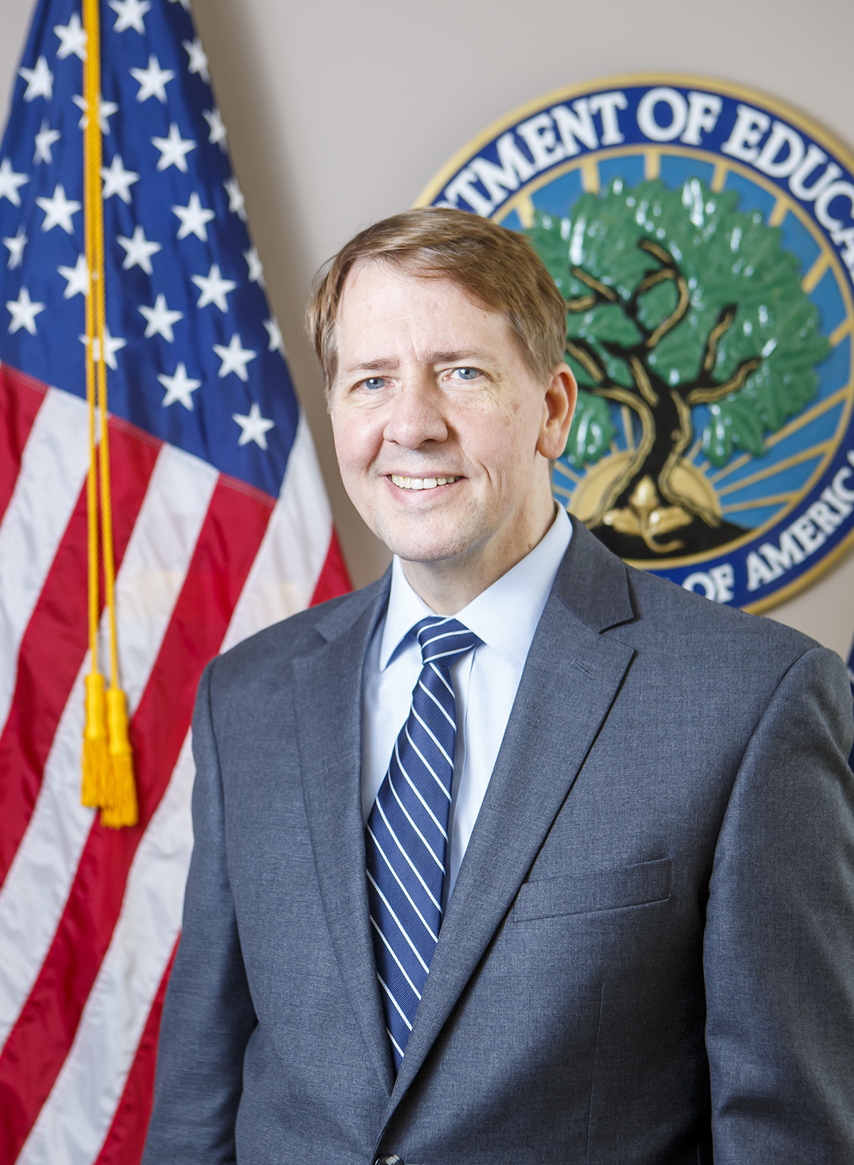
Richard Cordray
Chief Operating Officer, Federal Student Aid
U.S. Department of Education

Richard A. Cordray is the chief operating officer for the U.S. Department of Education office of Federal Student Aid (FSA). FSA administers the federal student aid programs, which—in Fiscal Year 2020—provided more than $115 billion in federal grants, loans, and work-study funds to 10.8 million students at nearly 5,600 schools. In total, FSA oversees a federal student loan portfolio valued at more than $1.5 trillion representing more than 45 million customers.
Cordray is responsible for strategic and operational management of FSA. He brings extensive leadership and expertise to this role, as well as a commitment to serving consumers and American families. His public service includes several senior state and federal positions, including as the first director of the Consumer Financial Protection Bureau (CFPB) from 2012 and 2017.
During his CFPB tenure, the agency brought enforcement actions that returned more than $12 billion to 30 million Americans. The CFPB created a consumer response system that gave people a voice; more than 1.3 million people had financial issues resolved by the new system. Under Cordray’s leadership, CFPB also adopted new rules to safeguard the multi-trillion-dollar mortgage market and took significant steps to protect student loan borrowers against abuses.
Before joining CFPB, Cordray served as the Ohio Attorney General, where he and his team recovered more than $2 billion for Ohio’s retirees, investors, and business owners and took major steps to protect consumers from fraudulent foreclosures and financial predators. Cordray also served as the Ohio Treasurer, where he led the state’s banking, investment, debt, and financing activities; as Ohio’s first Solicitor General; and in the Ohio General Assembly.
Cordray majored in legal and political theory at Michigan State University’s James Madison College. He earned a master’s degree in philosophy, politics, and economics while a Marshall Scholar at Oxford University in England. He then earned a law degree from the University of Chicago Law School, where he was editor-in-chief of the Law Review. He clerked for Judge Robert Bork on the U.S. Court of Appeals for the District of Columbia Circuit and for Justices Byron White and Anthony Kennedy on the U.S. Supreme Court. He has since argued seven cases before the U.S. Supreme Court and was a professor of constitutional law for many years.
Cordray is married and is the father of twins who are college graduates in the Class of 2021.

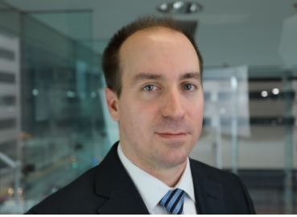
Joshua Garrison
Associate Commissioner for Legislation and Program Implementation
Indiana Commission for Higher Education

Josh Garrison is the Associate Commissioner for Legislation and Program Implementation with the Indiana Commission for Higher Education, where he is responsible for the Commission’s legislative agenda. While at the Commission, Josh has on focused improving Indiana’s state financial aid programs, increasing opportunities for returning adults, and implementing the Next Generation Hoosier Educators Scholarship. Prior to joining the Commission, he held positions with Iowa State University and the Michigan Department of Human Services. Josh holds a B.S. in Politics and Government from Illinois State University and a J.D. from the Southern Illinois University School of Law.

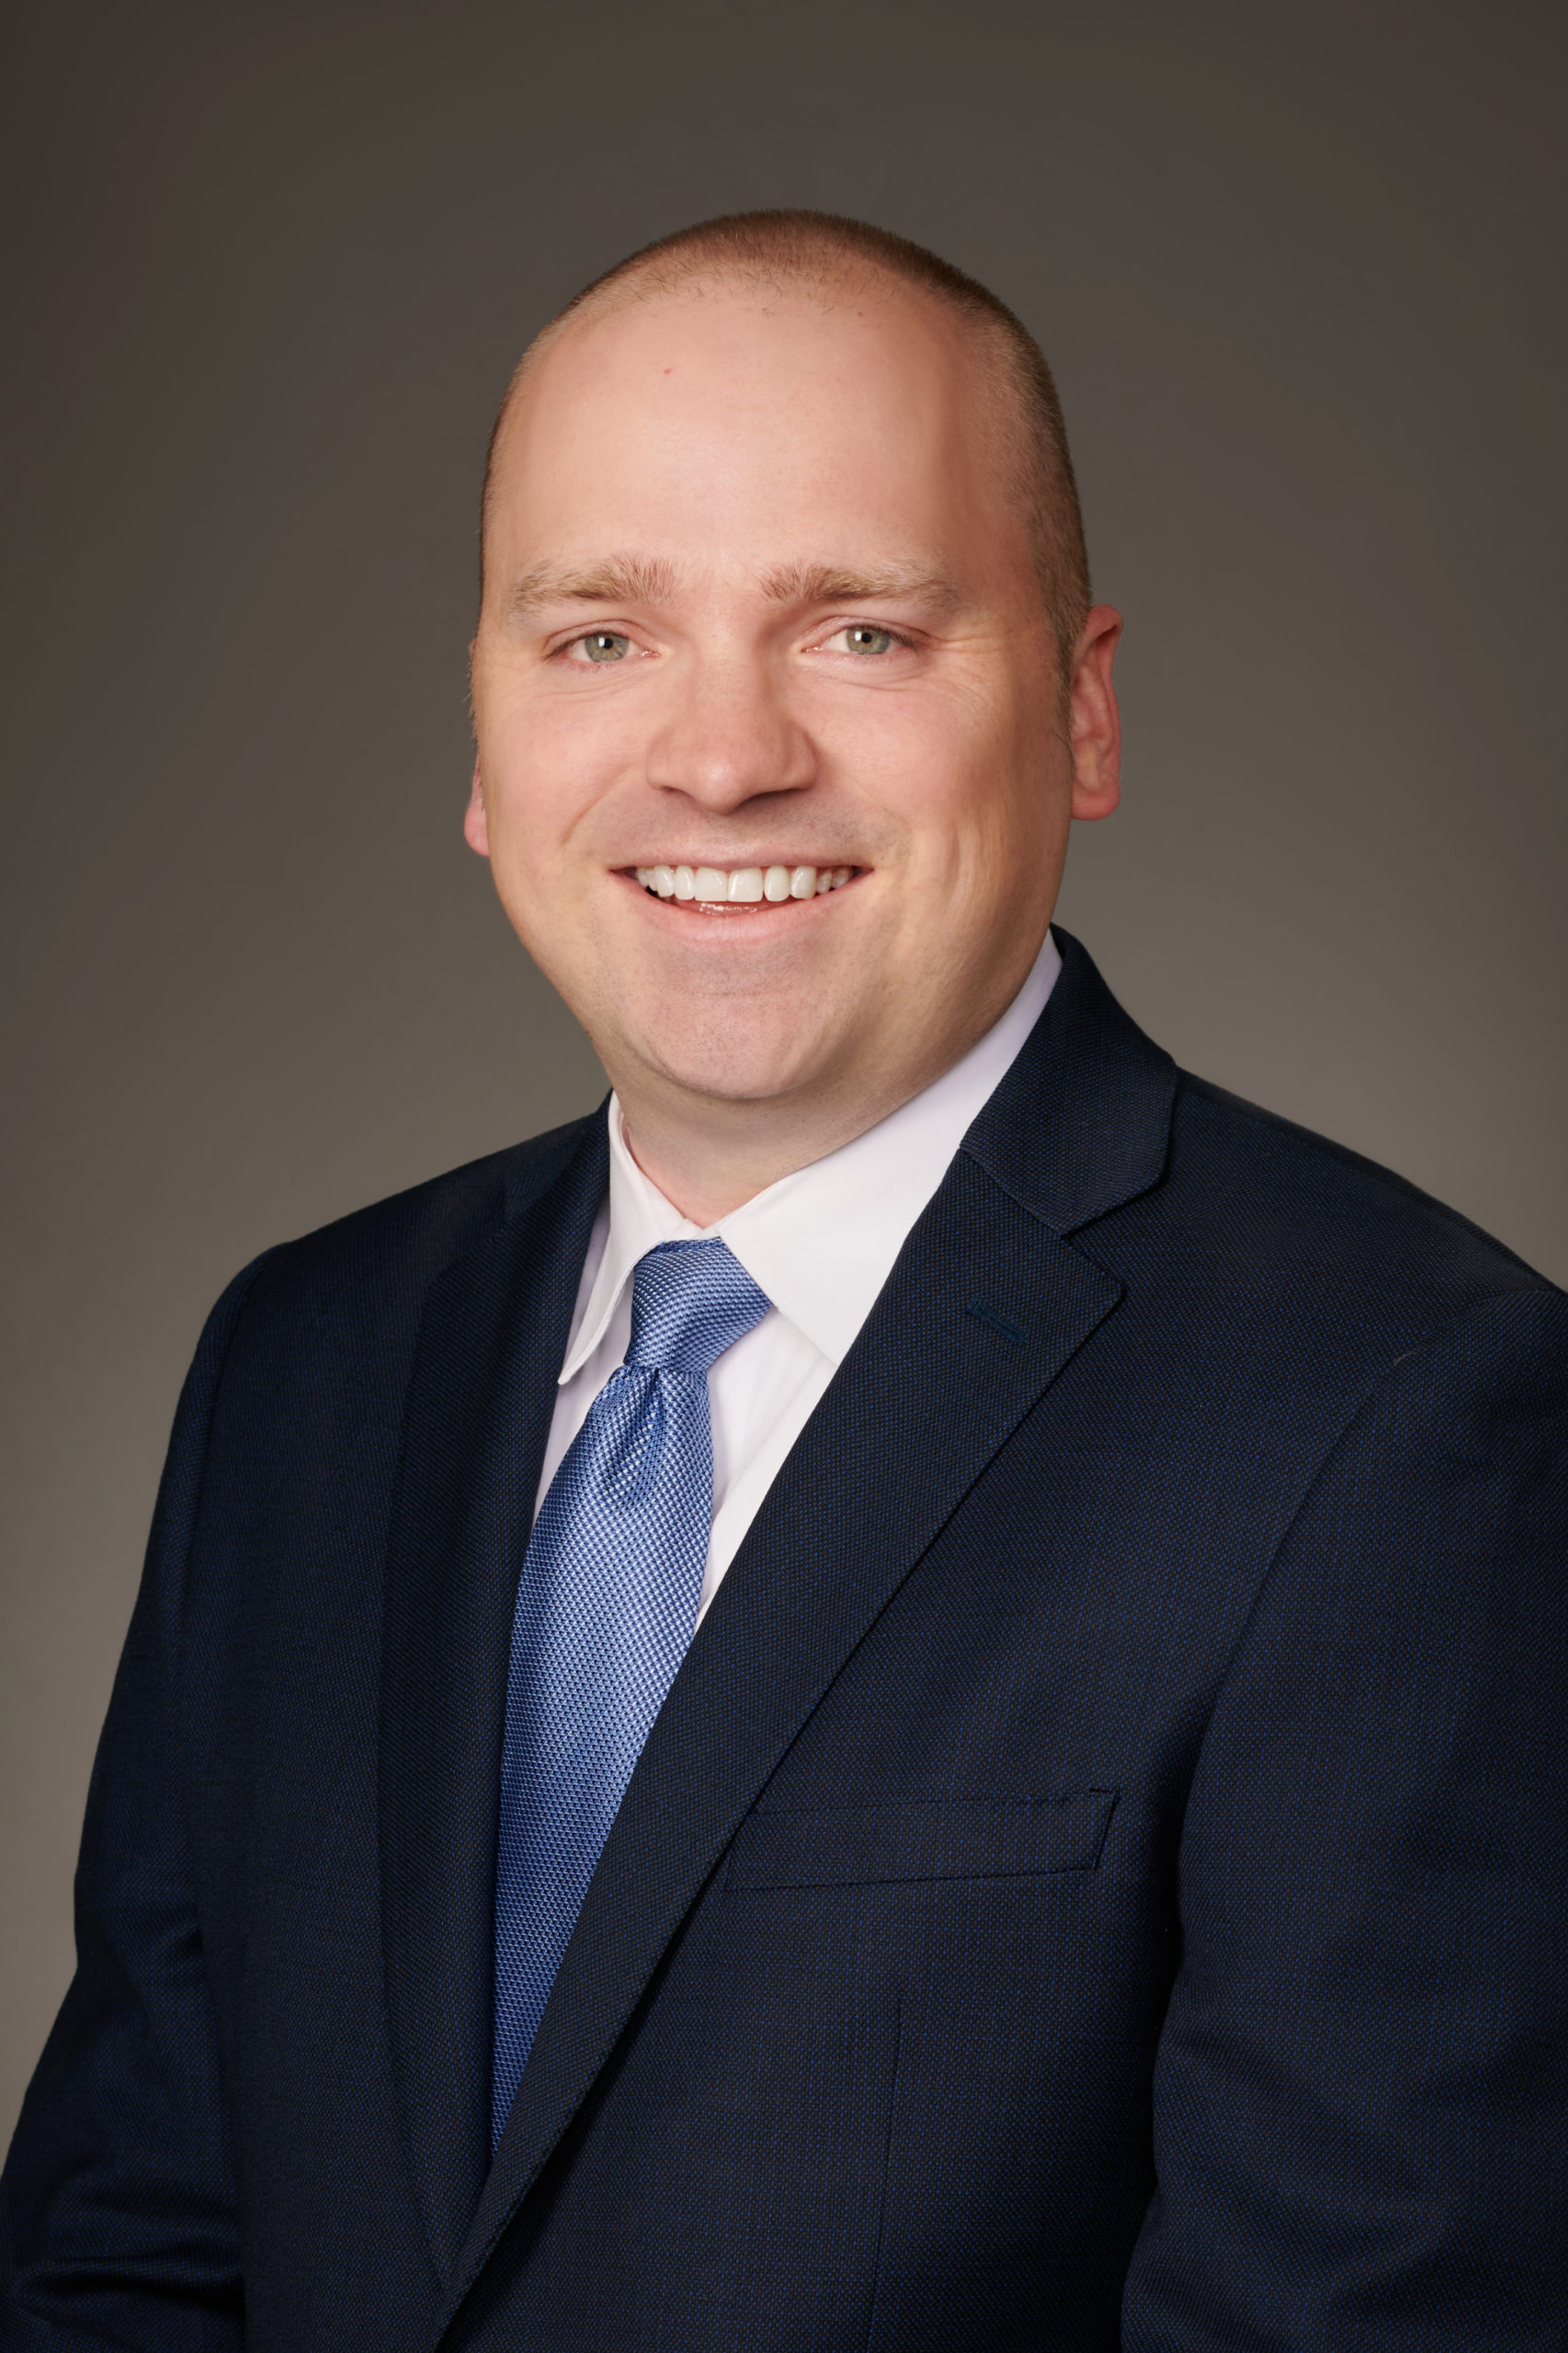
Thomas L. Harnisch, Ed.D.
Vice President for Government Relations
State Higher Education Executive Officers Association (SHEEO)

Dr. Tom Harnisch joined SHEEO in January 2020. As vice president for government relations, Dr. Harnisch is located in Washington, D.C., where his primary leadership responsibility is planning, implementing, and coordinating SHEEO’s portfolio of federal relations, policy, communication, and advocacy work. He monitors new and potential federal action (legislation, rules, and other policies and actions) that have relevance for our membership. Dr. Harnisch is responsible for bringing these issues to the attention of SHEEO staff and SHEEO’s membership and for articulating their potential impact on our members and the institutions and students they serve.
From 2007 to 2019, Dr. Harnisch worked in a series of roles at the American Association of State Colleges and Universities (AASCU), including as director of state relations and policy analysis. In his role at AASCU, his roles included policy research, analysis, and communication to the AASCU membership and other external stakeholder groups. He helped craft the AASCU Public Policy Agenda and planned the Higher Education Government Relations Conference. His research interests and commentary on higher education finance, access, affordability, and other topics have been cited in over 200 articles, including The New York Times, The Washington Post, Politico, Inside Higher Ed, and The Chronicle of Higher Education. He is also an adjunct faculty member at Georgetown University and The George Washington University. Dr. Harnisch earned a bachelor’s degree from the University of Wisconsin-Madison, a master’s from the University of Minnesota, and a doctorate from The George Washington University.

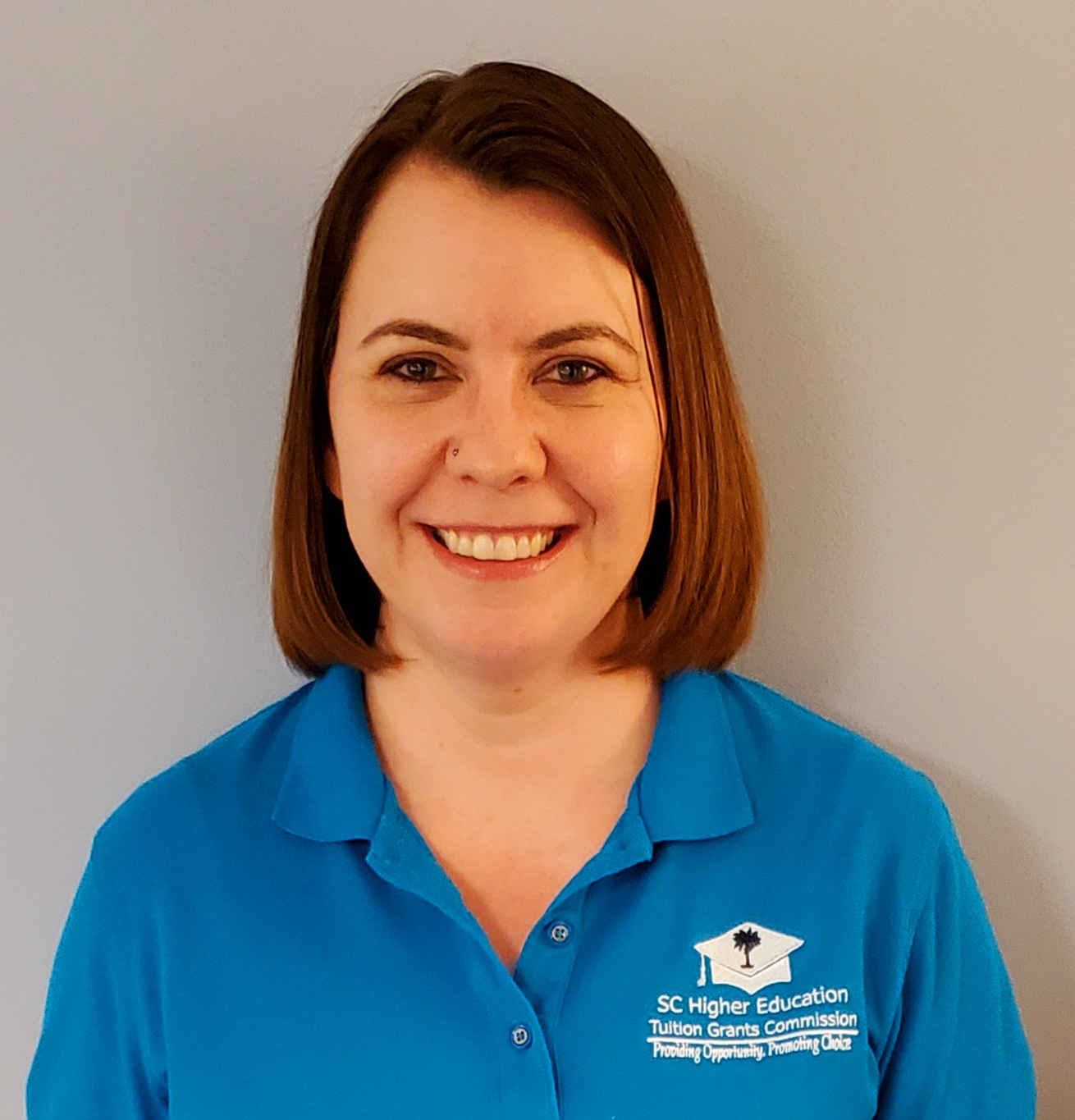
Katie Harrison

Executive Director

South Carolina Higher Education Tuition Grants Commission

Katie Harrison is the Executive Director of the South Carolina Higher Education Tuition Grants Commission and has been with the agency since 2009. Prior to her career with the Commission, Katie worked in student financial aid for Abraham Baldwin Agricultural College, Lander University, and the University of South Carolina. She has been a member of NASSGAP since 2009 and has served on the Executive Committee of the Association as Secretary and Membership Chair, in addition to her current role as President-Elect. Katie is also an active member of the South Carolina Association of Student Financial Aid, where she has served in numerous positions, including Conference Chair, Secretary, and President, and has been honored by SCASFAA as the recipient of their Emerging Leader, Achiever, and Fearless Nine Service awards. She has also volunteered on the Executive Board of the Southern Association of Student Financial Aid numerous times, including as Conference Chair in 2019.

Katie received her Bachelor’s Degree in Communications from Oglethorpe University and her Master’s Degree in Higher Education Administration from the University of South Carolina. She also holds the Certified Information Privacy Professional designation from the International Association of Privacy Professionals.

Moira Lenehan-Razzuri
Senior Policy Advisor
Office of Senator Jack Reed of Rhode Island

Moira Lenehan-Razzuri is the senior policy advisor for education, labor, child welfare, arts, and humanities for Senator Jack Reed of Rhode Island. She also served as the education policy advisor for Representative Ruben Hinojosa of Texas, who was chairman of the Education Task Force for the Congressional Hispanic Caucus. In addition to her legislative experience, Moira has worked as an education advocate and has managed college internship programs. She is a graduate of Georgetown University.

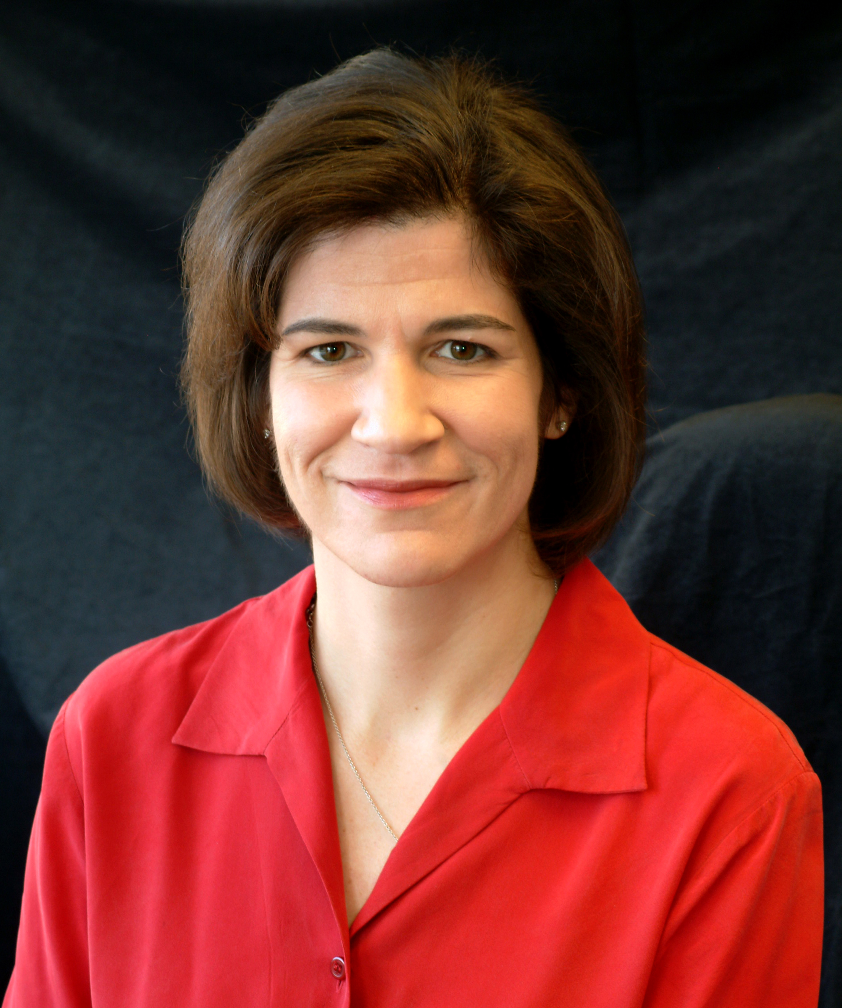
Karen McCarthy
Director of Policy Analysis
National Association Student Financial Aid Administrators (NASFAA)

Karen is the Director of Policy Analysis at NASFAA. She began her career in student aid working in the financial aid offices at several large, 4-year institutions, including Boston University, Miami University of Ohio, and The Ohio State University. She serves on the Department of Education’s FAFSA Advisory Group and FUTURE Act Implementation Group, and has served as NASFAA’s representative at negotiating rulemaking sessions, most recently covering Accreditation and Innovation in 2019. She has worked with various NASFAA task forces including Reauthorization, Campus-based Allocation Formula, Public Service Loan Forgiveness, Graduate and Professional Issues, FAFSA Simplification, “One Grant One Loan”, and R2T4.
A native of Massachusetts, she earned a bachelor’s degree from Cornell University and a master’s degree from The Ohio State University.

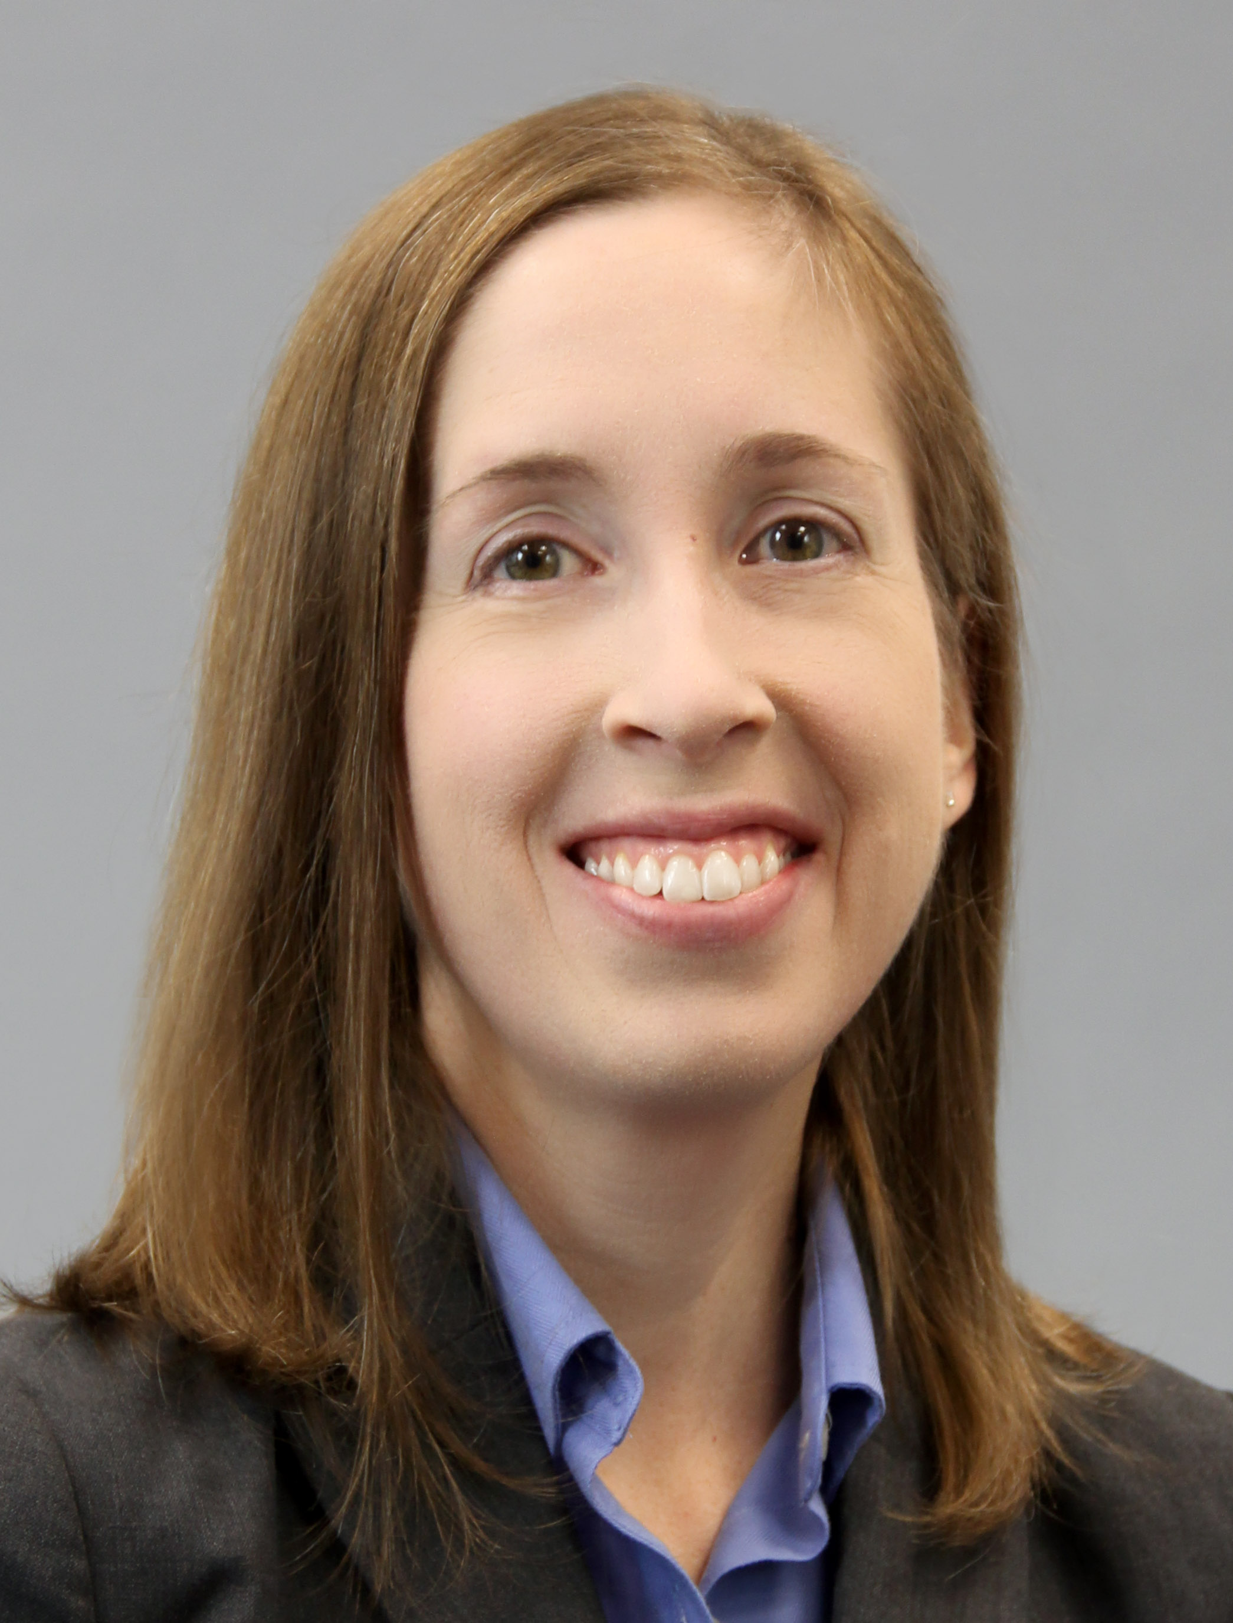
Elizabeth K. McCloud
Vice President, State Grant and Special Programs
Pennsylvania Higher Education Assistance Agency (PHEAA)

Elizabeth returned to PHEAA in September 2015, following 20 years of work in higher education, most recently serving 10 years as Director of Financial Aid at Elizabethtown College. As Vice President she provides leadership, strategic planning, management and administration of policies that govern or impact the State Grant and Special Programs area, with an emphasis on the policy impact for students and postsecondary institutions. Elizabeth is active in the Pennsylvania financial aid community and devoted to the support of student access to postsecondary education. Elizabeth currently serves as Chair of the NASSGAP Federal Relations Committee.

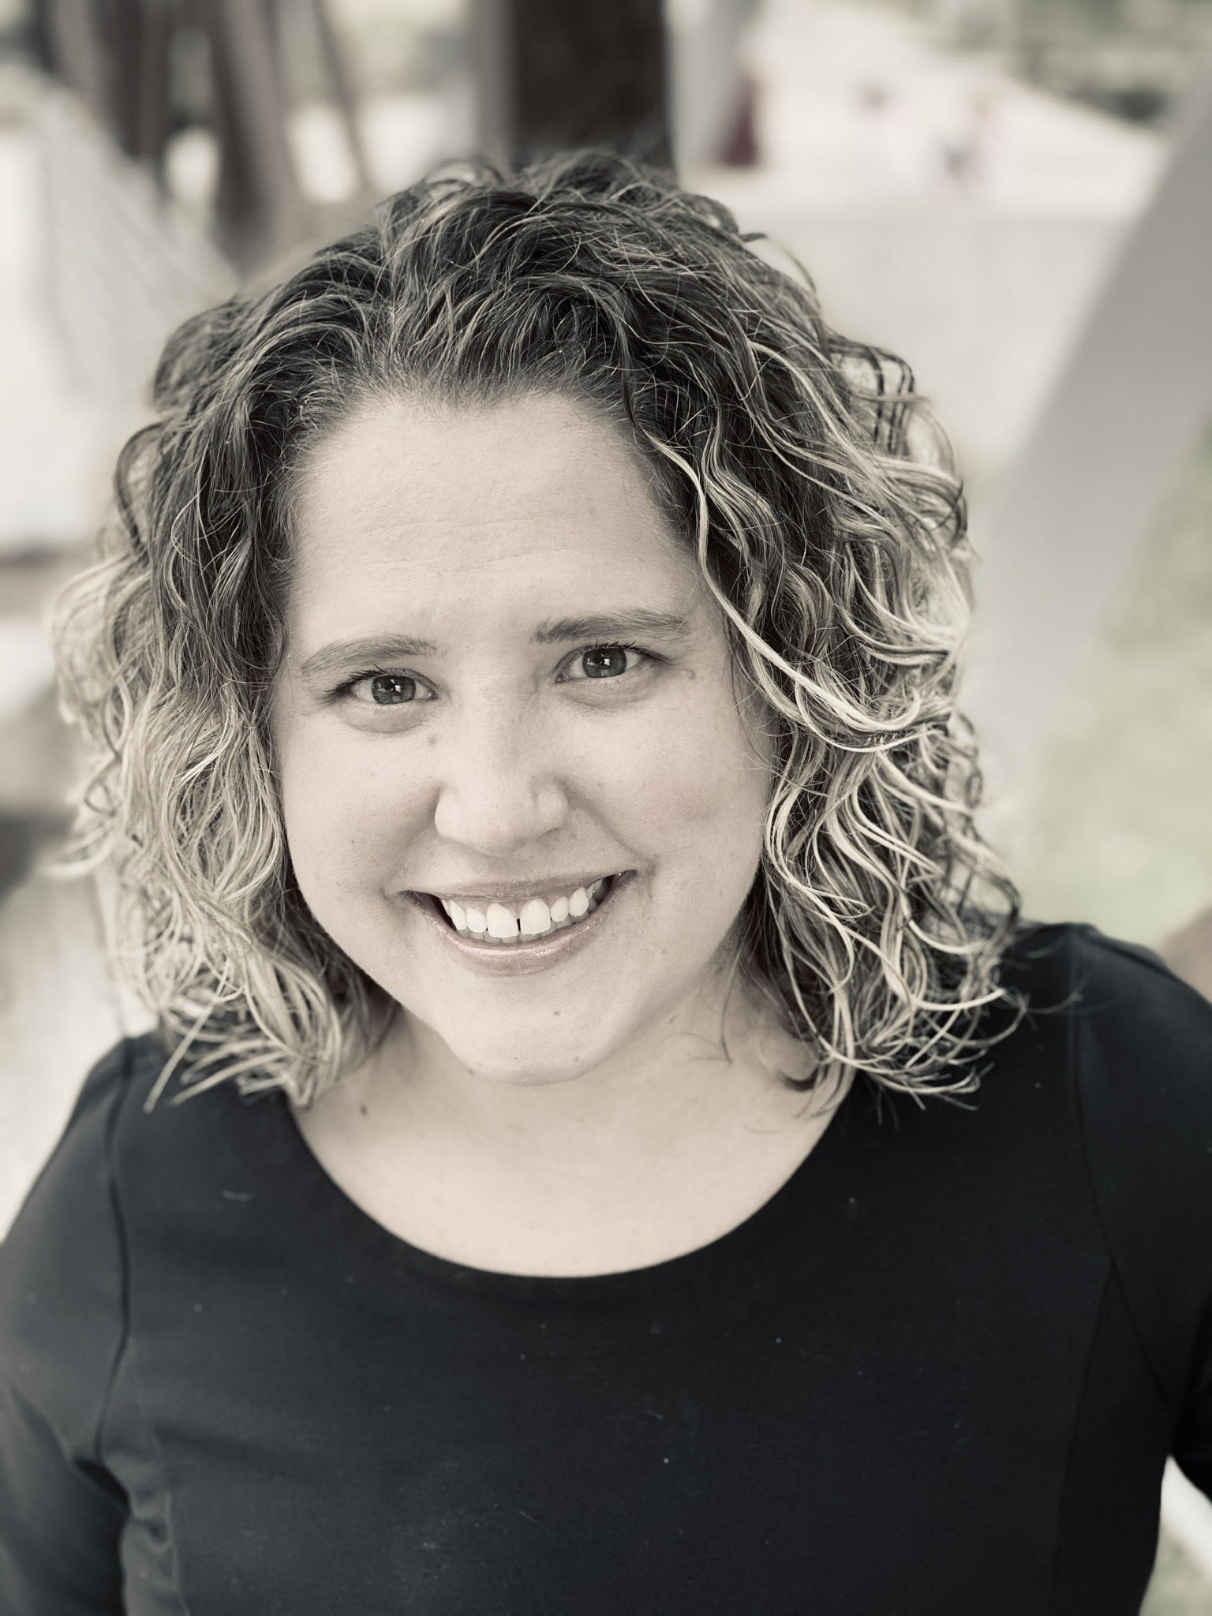
Meghan Oster, Ph.D.
Division Administrator for Research and Communications
Iowa College Aid

Dr. Meghan Oster is Division Administrator for Research and Communications Iowa College Aid. She earned a B.A. in Psychology from DePauw University, a M.S. in Higher Education and Student Affairs from Baylor University, and a PhD in Higher Education Administration from the University of Michigan’s Center for the Study of Higher and Postsecondary Education. Prior to working at Iowa College Aid, she worked at Northern Virginia Community College in institutional research. She researches higher education finance, financial aid, and student loans.

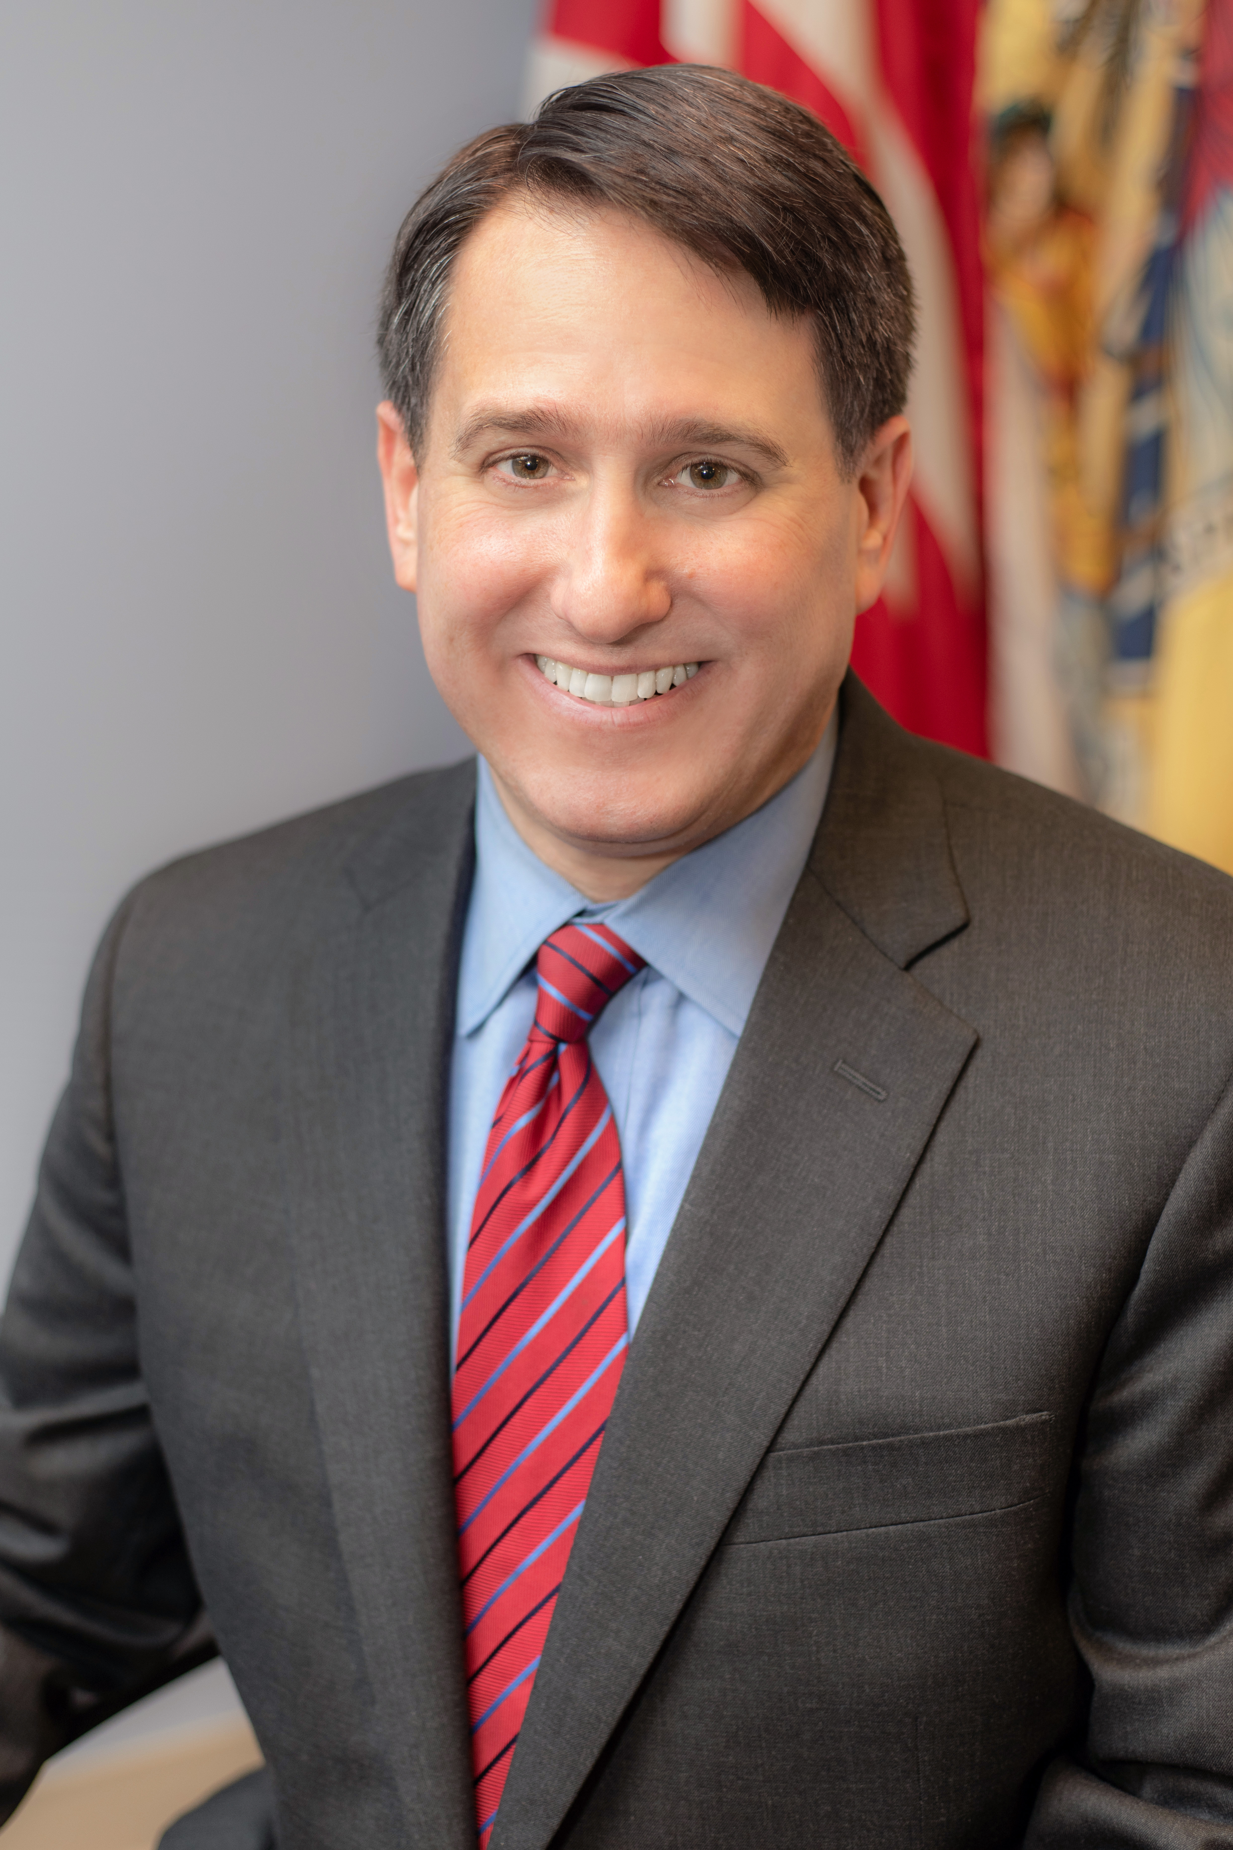
David J. Socolow
Executive Director
New Jersey Higher Education Student Assistance Authority
Mr. Socolow was appointed Executive Director of the New Jersey Higher Education Student Assistance Authority by Governor Philip Murphy in February 2018. Throughout his career in federal and state government and in the private sector, he has worked to advance the success of students and working families. Immediately prior to joining HESAA, Mr. Socolow was the director of the Center for Postsecondary and Economic Success at CLASP, a national non-profit policy advocacy organization, where he led initiatives to help low-income individuals attain the credentials they need to secure high-quality jobs by developing comprehensive career pathways and improving access and affordability of postsecondary education and workforce training. He served as Commissioner of the New Jersey Department of Labor and Workforce Development from 2006-2010, and previously served as director of New Jersey’s Unemployment Insurance Division and as senior advisor to the deputy secretary in the U.S. Department of Labor. He also worked as vice president for corporate affairs at the New Jersey headquarters of Pinnacle Foods, Inc., and chief of staff for former Congressman Robert E. Andrews. Mr. Socolow earned his bachelor’s degree from Harvard University and his master’s degree in public administration from Rutgers University.

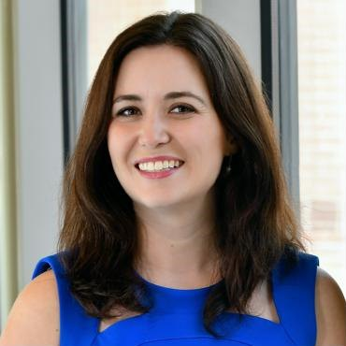
Carrie Warick
Director of Policy and Advocacy
National College Access Network (NCAN)

Ms. Carrie Warick is the director of policy and advocacy for the National College Attainment Network. She leads NCAN’s policy and advocacy work to promote policies that support students who are low-income, first-generation, or of color access and succeed in higher education. This includes managing NCAN's policy priorities at both the federal and state level.

