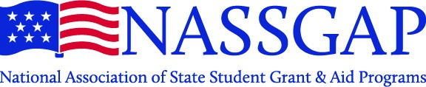

NATIONAL ASSOCIATION OF STATE STUDENT GRANT AND AID PROGRAMS
Annual Business Meeting
Thursday, October 15, 2020 – 1 p.m. PDT/2 p.m. MDT/3 p.m. CDT/4 p.m. EDT

AGENDA

- Call to Order

- Review and Approve Meeting Minutes from October 24, 2019

- Officer Reports
  - President – Jennifer Rogers
  - Past-President – Elizabeth McDuffie
  - President Elect – Todd Brown
  - Treasurer – Leroy Wade
  - Secretary – Jennifer Lanphear
  - Members at Large (Conference Co-Chairs) – Deena Lager and Renée Davis

- Committee Reports
  - Web – Ritchie Morrow
  - Membership – Katie Harrison
  - Ed Technical – Donna Thomas
  - Federal Relations – Elizabeth McCloud

- Consideration of Proposed By-Laws Changes

- Old Business

- New Business

- Passing of the Gavel

- Adjournment

