NASSGAP Conference 2017 – Planning Meetings

Meeting 1 - February 27, 2017
- Registration – NC will host again ? – will improve the questions to clarify what the cost covers
- Promotion – We did a “Save the Date” last year in April – should we do this again?
- Budget
  - food cost estimates
  - AV costs – highly suggested to rent the projector
  - Registration rate?
  - President’s reception – suggested to include entertainment
- Hotel – room block
- Buddy for the new attendees – ie. dinner on own
- Program Ideas – around 17 time slots to fill
  - Survey in process – highlights
    - New administration’s plan for higher education
    - Update from FSA under the new administration
    - Linking state aid to state goals
    - Hottest issues in higher education, especially once closer to conference-changing landscape
    - Program design to incent completion
    - Translating data collection and analysis into policy change @ state level
    - FAFSA early awarding results from states
    - Financial aid reform within the states
    - FAFSA simplification results and issues
    - Efforts to increase FAFSA completions and evidence of an increase of low income students attending
    - Hear from states regarding data they collect, how to evaluate program effectiveness/impact on recipient, and recipient behavior
    - State based work study programs
    - Highlight one or two state programs and have the state go into detail about the grant program, what works, challenges, etc… Give us more knowledge of what our peer states are doing and also is a great source of new ideas to consider.
  - Roll call ideas
    - Expand
    - Move up in agenda – days 1 and 2
    - Variety of topics so not repetitive
    - Veteran present first then new attendees?
  - Consolidation of regulatory/legislation
    - potential presenters – NCHER, NASFAA, Fed Update, DOE, staffers
  - Executive Committee on 10/24 – suggested on survey to be a full day
  - Suggested to make lunch longer
  - Formal Introductions and acknowledge newbies – place on agenda
    - ie. - 30 minutes for welcome (Clantha) and intros
    - pictures
  - Host state (DC) happenings

  - Early FAFSA Implementation – focus on the rate of completion, projects within states, Colorado Professional Learning Community, state perspective on moving up the award date, impact
    - Statewide Framework – Stephanie Ricker, CO, willing to present – a new twist on the impact of implementation
  - Engage adult learners – updating skills, part-time, modes of deliver, etc…; we had this in 2016, what would be a new twist?
  - Workforce Initiatives – focus on attainment and completion
  - “Knocking At College’s Door” – WICHE series
    - Sarah Ohle Leibrandt is willing to present.
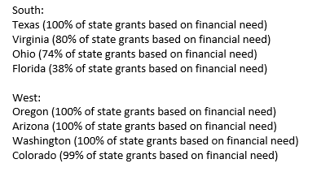
    - Prefers an engaging panel of few states where need-based aid makes up the majority of the aid. Look at states with the highest projected growth to sit on the panel. She suggests:

  - Friday will need to be an engaging session if roll call is moved to day 1 and 2
- Other

